Principle Component Analysis using R.

**What is principal component analysis?**

* **Principal Component Analysis** (**PCA**) is a dimension-reduction tool that can be **used** to reduce a large set of variables to a small set that still contains most of the information in the large set.
* **Principal component analysis** (**PCA**) is used to summarize the information in a data set described by multiple variables.
* Note that, the information in a data is the total **variation** it contains.
* **PCA reduces the dimensionality** of data containing a large set of variables. This is achieved by transforming the initial variables into a new small set of variables without loosing the most important information in the original data set.
* These new variables corresponds to a **linear combination** of the originals and are called **principal components**.

This article describes, step by step, how PCA works using **R software**.

**PCA basics**

* Understanding the details of PCA requires knowledge of linear algebra. In this section, we’ll explain the basics with simple graphical representation of the data -

In the Figure 1A below, the data are represented in the X-Y coordinate system. The dimension reduction is achieved by identifying the principal directions, called **principal components**, in which the data varies.

**PCA** assumes that the directions with the largest variances are the most “important” (i.e, the most principal).

In the figure below, the *PC1 axis* is the **first principal direction** along which the samples show the largest variation. The **PC2 axis** is the **second most important direction** and it is **orthogonal** to the PC1 axis.

The dimensionality of our two-dimensional data can be reduced to a single dimension by projecting each sample onto the first principal component (Figure 1B)

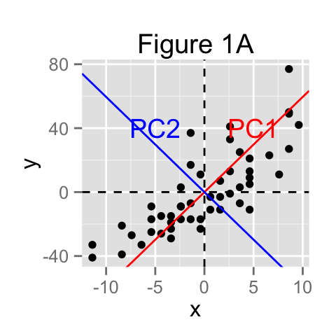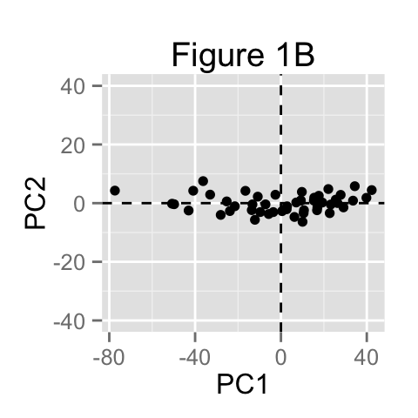

**Main purpose of PCA**

The main goals of **principal component analysis** is :

* to identify hidden pattern in a data set
* to reduce the dimensionnality of the data by removing the noise and redundancy in the data
* to identify correlated variables

PCA method is particularly useful when the variables within the data set are highly correlated.

**Correlation** indicates that there is **redundancy** in the data. Due to this redundancy, PCA can be used to reduce the original variables into a smaller number of new variables ( = **principal components**) explaining most of the variance in the original variables.

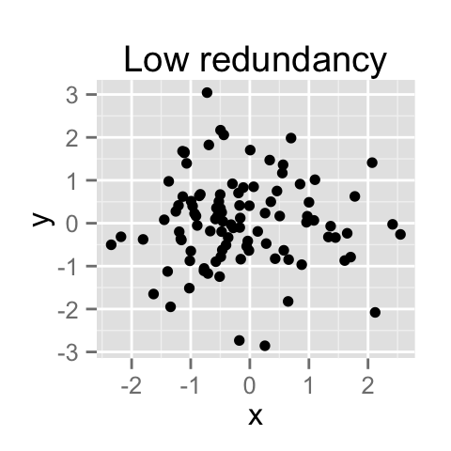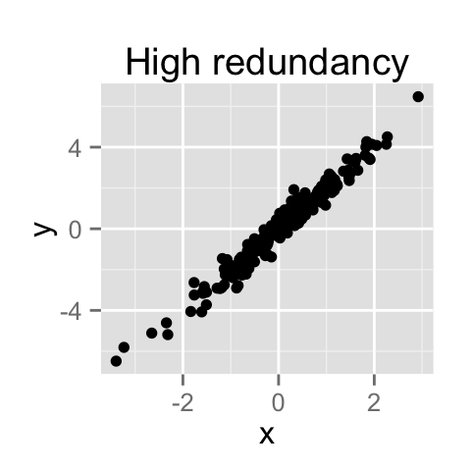

How to remove the redundancy?

PCA is traditionally performed on covariance matrix or correlation matrix.

**Basic statistics - Covariance between two variables**

Let x and y be two variables with length n.

The variance of x is :

σ2xx=∑i(xi−mx)(xi−mx)n−1σxx2=∑i(xi−mx)(xi−mx)n−1

The variance of y is :

σ2yy=∑i(yi−my)(yi−my)n−1σyy2=∑i(yi−my)(yi−my)n−1

The covariance of x and y is :

σ2xy=∑i(xi−mx)(yi−my)n−1σxy2=∑i(xi−mx)(yi−my)n−1

mxmx and mymy are the means of x and y variables, respectively.

The covariance measures the degree of the relationship between x and y.

**Covariance/correlation matrix**

A covariance matrix contains the covariances between all possible pairs of variables in the data set :

df <- iris[, -5]

res.cov <- cov(df)

round(res.cov,2)

Sepal.Length Sepal.Width Petal.Length Petal.Width

Sepal.Length 0.69 -0.04 1.27 0.52

Sepal.Width -0.04 0.19 -0.33 -0.12

Petal.Length 1.27 -0.33 3.12 1.30

Petal.Width 0.52 -0.12 1.30 0.58

Note that, the covariance matrix is symmetric. In the table above, covariance between Sepal.Length and Sepal.Width = covariance between Sepal.Width and Sepal.Length.

**Interpretention of the covariance matrix**

1. The diagonal elements are the **variances** of the different variables. **A large diagonal values correspond to strong signal**.

diag(res.cov)

Sepal.Length Sepal.Width Petal.Length Petal.Width

0.6856935 0.1899794 3.1162779 0.5810063

1. The off-diagonal values are the **covariances** between variables. They reflect distortions in the data (noise, redundancy, …). **Large off-diagonal values correspond to high distortions in our data**.

The aim of PCA is to minimize this distortions and to summarize the essential information in the data

**How to minimize the distortion in the data ?**

In the covariance table above, the off-diagonal values are different from zero. This indicates the presence of redundancy in the data. In other words, there is a certain amount of correlation between variables.

This kind of matrix, with non-zero off-diagonal values, is called **“non-diagonal” matrix**.

We need to redefine our initial variables (x, y, z, ….) in order to diagonalize the covariance matrix.

This means that we want to change the covariance matrix so that the off–diagonal elements are close to zero (i.e, zero correlation between pairs of distinct variables).

The new variables (x’, y’, z’, …) are a linear combination of the old ones :

X′=a1X+a2Y+a3Z,...X′=a1X+a2Y+a3Z,...

Y′=b1X+b2Y+b3Z,...Y′=b1X+b2Y+b3Z,...

In PCA, the constants a1, a2, an, b1, b2, bn are calculated such that the covariance matrix is diagonal.

**PCA terminologies : Eigenvalues / eigenvectors**

**Eigenvalues** : The numbers on the diagonal of the diagonalized covariance matrix are called eigenvalues of the covariance matrix. Large eigenvalues correspond to large variances.

**Eigenvectors** : The directions of the new rotated axes are called the eigenvectors of the covariance matrix.

**Eigenvalues** and **eigenvectors** can be easily calculated in R as follow :

eigen(res.cov)

$values

[1] 4.22824171 0.24267075 0.07820950 0.02383509

$vectors

[,1] [,2] [,3] [,4]

[1,] 0.36138659 -0.65658877 -0.58202985 0.3154872

[2,] -0.08452251 -0.73016143 0.59791083 -0.3197231

[3,] 0.85667061 0.17337266 0.07623608 -0.4798390

[4,] 0.35828920 0.07548102 0.54583143 0.7536574

The **first principal components** of the data are the first directions explaining maximum variances. This is equivalent to the first eigenvectors of the covariance matrix.

**Steps for principal component analysis**

The procedure includes 5 simple steps :

1. **Prepare the data** :

* *Center the data* : subtract the mean from each variables. This produces a data set whose mean is zero.
* *Scale the data* : If the variances of the variables in your data are significantly different, it’s a good idea to scale the data to unit variance. This is achieved by dividing each variables by its standard deviation.

1. **Calculate the covariance/correlation matrix**
2. **Calculate the eigenvectors and the eigenvalues** of the covariance matrix
3. **Choose principal components** : eigenvectors are ordered by eigenvalues from the highest to the lowest. The number of chosen eigenvectors will be the number of dimensions of the new data set. eigenvectors = (eig_1, eig_2,…, eig_n)
4. **compute the new dataset** :

* *transpose eigeinvectors* : rows are eigenvectors
* *transpose the adjusted dat*a (rows are variables and columns are individuals)
* *new.data* = eigenvectors.transposed X adjustedData.transposed

**Compute principal component analysis (step by step)**

The data set *iris* is used : columns are variables and rows are observations:

df <- iris[, -5]

head(df)

Sepal.Length Sepal.Width Petal.Length Petal.Width

1 5.1 3.5 1.4 0.2

2 4.9 3.0 1.4 0.2

3 4.7 3.2 1.3 0.2

4 4.6 3.1 1.5 0.2

5 5.0 3.6 1.4 0.2

6 5.4 3.9 1.7 0.4

**1. Center and scale the data**

df.scaled <- scale(df, center = TRUE, scale = TRUE)

**2. Compute the correlation matrix** :

# 1. Correlation matrix

res.cor <- cor(df.scaled)

round(res.cor, 2)

Sepal.Length Sepal.Width Petal.Length Petal.Width

Sepal.Length 1.00 -0.12 0.87 0.82

Sepal.Width -0.12 1.00 -0.43 -0.37

Petal.Length 0.87 -0.43 1.00 0.96

Petal.Width 0.82 -0.37 0.96 1.00

**3. Calculate the eigenvectors/eigenvalues** of the correlation matrix :

# 2. Calculate eigenvectors/eigenvalues

res.eig <- eigen(res.cor)

res.eig

$values

[1] 2.91849782 0.91403047 0.14675688 0.02071484

$vectors

[,1] [,2] [,3] [,4]

[1,] 0.5210659 -0.37741762 0.7195664 0.2612863

[2,] -0.2693474 -0.92329566 -0.2443818 -0.1235096

[3,] 0.5804131 -0.02449161 -0.1421264 -0.8014492

[4,] 0.5648565 -0.06694199 -0.6342727 0.5235971

The first eigenvalue (*2.9*) is much larger than the second (*0.9*), and so on…. The highest eigenvalues correspond to the first data principal components.

**5. compute the new dataset** :

# Transpose eigeinvectors

eigenvectors.t <- t(res.eig$vectors)

# Transpose the adjusted data

df.scaled.t <- t(df.scaled)

# The new dataset

df.new <- eigenvectors.t %*% df.scaled.t

# Transpose new data ad rename columns

df.new <- t(df.new)

colnames(df.new) <- c("PC1", "PC2", "PC3", "PC4")

head(df.new)

PC1 PC2 PC3 PC4

[1,] -2.257141 -0.4784238 0.12727962 0.024087508

[2,] -2.074013 0.6718827 0.23382552 0.102662845

[3,] -2.356335 0.3407664 -0.04405390 0.028282305

[4,] -2.291707 0.5953999 -0.09098530 -0.065735340

[5,] -2.381863 -0.6446757 -0.01568565 -0.035802870

[6,] -2.068701 -1.4842053 -0.02687825 0.006586116

**Packages in R for the principal component analysis**

There are several functions from different packages for performing PCA :

* The functions **prcomp()** and **princomp()** from the built-in **R stats** package. Read more here: [prcomp and princomp](http://www.sthda.com/english/wiki/principal-component-analysis-the-basics-you-should-read-r-software-and-data-mining)
* **PCA()** from **FactoMineR** package. Read more here : [PCA with FactoMineR](http://www.sthda.com/english/wiki/factominer-and-factoextra-principal-component-analysis-visualization-r-software-and-data-mining)
* **dudi.pca()** from **ade4** package. Read more here : [PCA with ade4](http://www.sthda.com/english/wiki/ade4-and-factoextra-principal-component-analysis-r-software-and-data-mining)

**Infos**

This analysis has been performed using **R software** (ver. 3.1.2) and **ggplot2** (ver. 1.0.0)

Read more :

* Gregory B. Anderson, principal component analysis in R, <https://www.ime.usp.br/~pavan/pdf/MAE0330-PCA-R-2013>
* Wikibooks, <http://en.wikibooks.org/wiki/Data_Mining_Algorithms_In_R/Dimensionality_Reduction/Principal_Component_Analysis>
* Carlos Pinto, Data reduction, <https://medicine.tcd.ie/neuropsychiatric-genetics/assets/pdf/2009_7_PCA_+_Factor_analyses.pdf>